Ecosystem Services Exchange
The Business Case for Drainage Water Management
Executive Summary

Overview
Since the early 1900s, farmers have used drainage to bring land into production and increase yields. Agricultural drainage uses surface ditches and subsurface pipes to remove excess water from poorly drained land, and today over 100 million acres of U.S. farmland have been drained (see USDA graph below). While conventional drainage systems improve farm productivity, they are often detrimental because they can increase nutrient transport to water bodies.

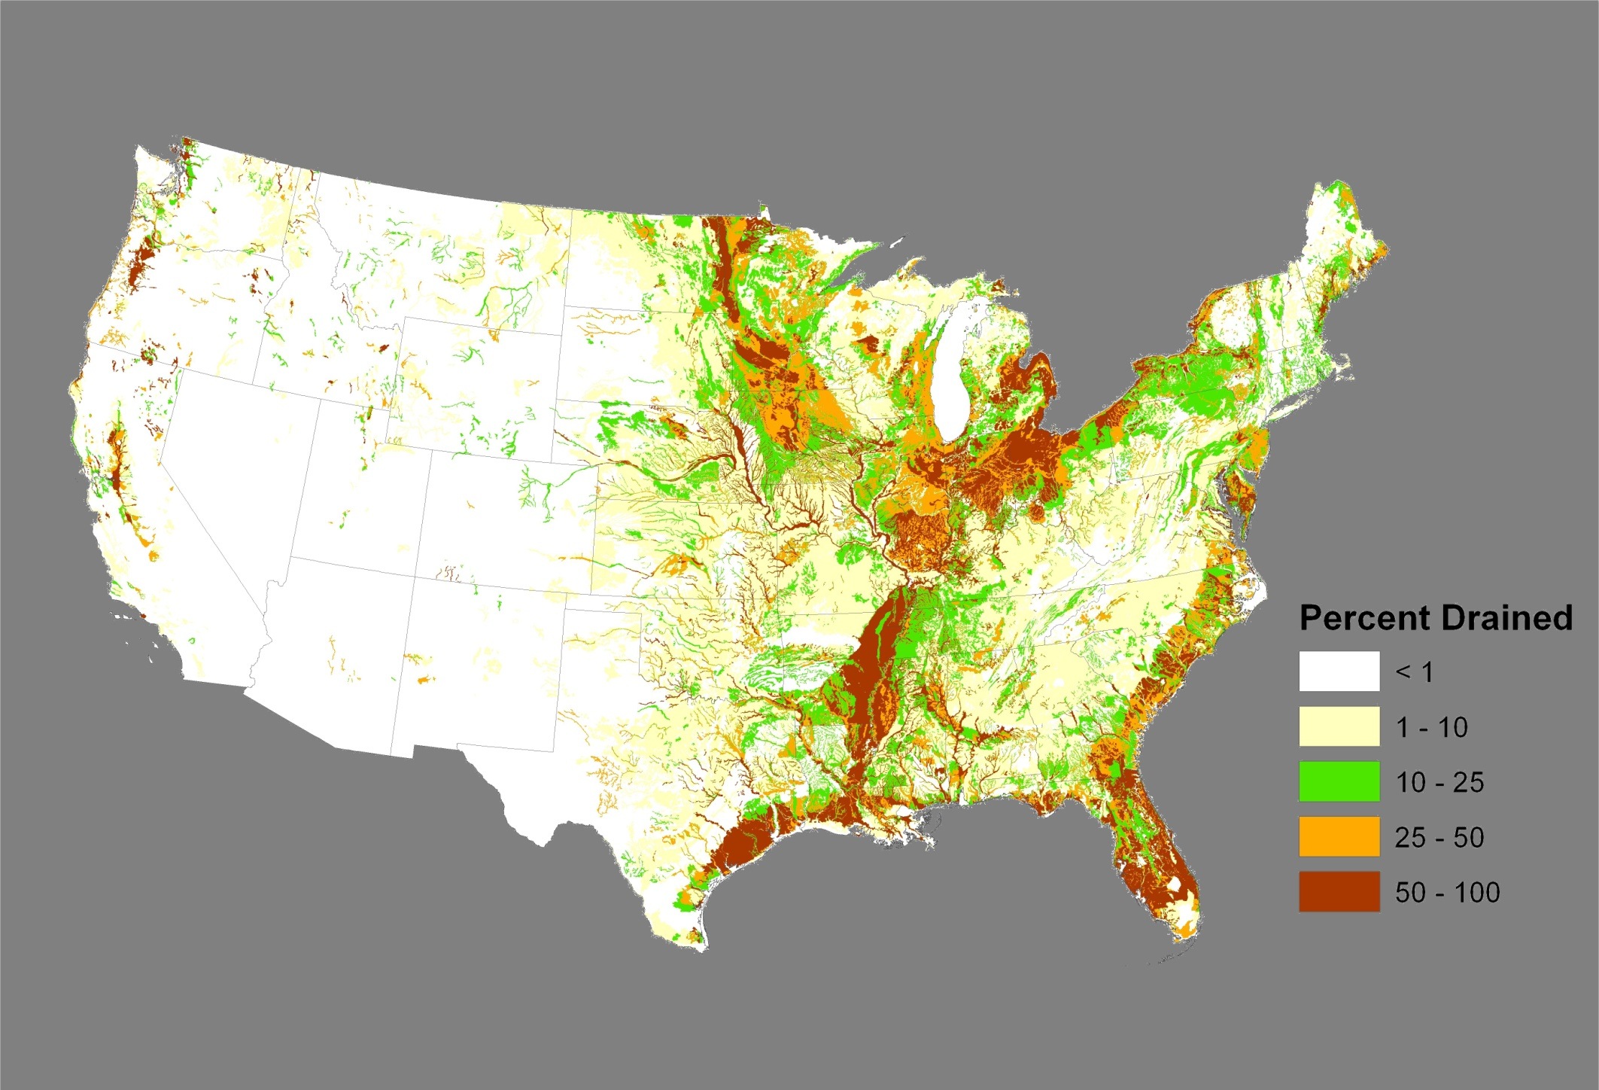
100 Million Acre Drainage Infrastructure on Agricultural Lands – USDA-NRCS

In draining these lands over the past century, we have altered the riparian functions of our primary, secondary, and small tributary streams. The loss of these systems means the ability to naturally strip nutrients from waters has been significantly reduced.

Ecosystem Services Exchange (ESE) provides technical assistance to design, implement, monitor, and manage drainage water management (DWM) systems that can substantially reduce nutrient loss into water bodies while also preserving or increasing yields. ESE is licensed to use several patented products, including systems and methods to remotely monitor and automatically manage water levels and flow rates in drained fields.

The ESE system allows retention of water in the field where dissolved nutrients benefit crop production rather than releasing them to surface waters where they impair water quality. Water that is discharged from the field can be directed to edge-of-field conservation practices such as saturated buffers, denitrifying bioreactors, or constructed wetlands which dramatically reduce nutrient levels and improve water quality. ESE has also improved on DWM by adding a Real-Time feature (DWM-RT). This technology employs two-way telemetry and greatly enhances managerial functions.

Because of the huge extent of drained land, ESE’s technology and suite of conservation practices represent a key business opportunity for those interested in improving both agricultural productivity and water quality; particularly source waters used for human consumption. The ESE system’s approach allows for the monitoring and quantification of nutrient reductions, and holds the possibility for generating nutrient credits in the emerging water quality trading markets.

While ESE’s practices and technologies can be applied throughout the nation, the greatest current growth area is in those regions which already have extensive drainage; particularly in the Midwest and Upper Midwest.

The Problem and Opportunity
High rates of nutrient contamination in the nation’s waters pose a significant threat to the environment and human health. Nutrient loss from agriculture, nitrogen (N) and phosphorous (P), is contributing to over enrichment of waterways causing eutrophication of both freshwater and marine ecosystems. The nutrients fuel harmful algal blooms (i.e. Western Lake Erie Basin) and results in massive die offs of aquatic organisms; creating hypoxic dead zones across the globe (i.e. Gulf of Mexico and Chesapeake Bay).

In addition, acute and chronic exposure to excess N and P concentration poses a threat to human health. In 2014, the City of Toledo, Ohio, had to shut down its entire water system due to a harmful algal bloom (https://www.ecowatch.com/toxic-algae-bloom-leaves-500-000-without-drinking-water-in-ohio-1881940537.html).

Much of this nutrient loading can be attributed to runoff from agricultural lands. Nutrient inputs are one of the most effective ways to increase agricultural productivity and profitability. Driven by growth in both population and affluence, the world is projected to need as much food in the next four decades as was produced in the previous 10,000 years combined. As a result, we can expect to see continued, if not increasing intensification of agriculture. Without intervening action, the delivery of nutrients from agriculture to our waters will likely continue and may even increase.

The agricultural industry is acutely aware of the role it plays impacting water quality and is concerned about regulatory actions that would effect on-farm decision making and increase production costs. As a result, most farmers are anxious to address the issue; providing it can be done cost-effectively.

The lack of a scalable, cost-effective strategy that can be readily adopted to reduce nutrient loading in our waterways is one of the most serious environmental problems we face today. This challenge has repeatedly been documented not only in hundreds of peer-reviewed articles but more significantly in the leading conservation critiques of our time such as the Millennium Ecosystem Assessment and the USDA Conservation Effects Assessment Project.

To address this issue, ESE offers a cost-effective solution to reducing nutrient loss in the nation’s waterways, and does so in a way that fosters cooperation rather than confrontation. We believe our approach offers an innovative strategy for farmers, businesses, municipalities, and permitted facilities to protect source waters and meet water quality requirements, and do so at less cost while preserving or improving crop productivity.

ESE income-producing services include:
- Planning: ESE staff plan and design conservation practices for both private entities and the federal government. ESE is a certified technical service provider to the USDA and work performed for the Department is reimbursable;
- Management & Operation of Patented Products: With exclusive agreements with agriculture producers and a water management equipment manufacturing company, ESE offers full system management services;
- Monitoring Conservation Effects: Using batch sampling, remote sensing, and proprietary systems, ESE monitors, measures, and quantifies environmental conditions such as rainfall, drainage system flow rates, and nutrient transport reductions delivered by management actions and structural practices; and
- Nutrient Credit Trading: ESE quantifies nutrient reductions for entities seeking to meet water quality requirements at less cost.

There are two immediate business opportunities for ESE:
- Technical assistance to design and implement DWM systems. Given the huge acreage where drainage exists, DWM is a primary area ripe for market penetration. Conventional drainage systems are designed to flow 24/7 without the ability to manage the volume and velocity exiting the system. DWM gives the farmer control of the system and improves both crop production and water quality. In addition, when a supplemental water source is available, subsurface irrigation systems can be designed, constructed, and managed to add water back into the system, reversing the drainage process and providing additional crop productivity and enhanced in-field nutrient use. An additional plus to sub-irrigation is that it typically uses about half the water and one quarter of the energy required of overhead center pivot irrigation. ESE designs systems to hold water in the field when it is needed and retain nutrients in the field where they are used by crops and prevents them from polluting waterways. Additionally, retaining water in fields can be critical to crop production during droughts. Each of these actions can significantly reduce risk for a producer thereby driving down their costs and increasing profitability.

- Post installation monitoring and management. Once a system is in place, the management and monitoring offer extensive income potential. For regulated entities, ESE’s green infrastructure approach can deliver results to communities and facilities at a lower cost when compared to conventional grey infrastructure, plus the systems will be in place and ready to use when environmental markets are established. ESE systems can also be managed to reduce flooding (holding water back in the soils and letting it out at controlled rates) and to enrich wildlife habitat (creating in-field ponding areas for cover, food, nesting, and brood rearing).

ESE services and products will play a major role in advancing the implementation of agricultural practices on drained land that is highly quantifiable, reliable, and transparent. It will also play a leading role in advancing a market-based approach to foster more conservation investment while at the same time providing a cost-effective way to meet environmental performance standards.

ESE’s Significant Advantages
ESE offers several key innovations and strategic competitive advantages. It is anticipated that municipalities will face literally a trillion dollars in infrastructure costs to meet Clean Water Act requirements over the next twenty years. We believe that water quality standards can be more cost effectively met through partnerships with agriculture.

The ESE Management Team has a competitive advantage with 30 years of experience in agricultural drainage control and more than 130 years cumulative experience in agriculture and conservation. We understand conservation, know agriculture, and are both known and respected within the agricultural community.

Farmer Acceptance
Top producers realize that water table management and subsurface irrigation are the ultimate steps to maximize productivity. A study by Iowa State University found that over a 62-year period, 67 percent of the causes for crop loss in corn was either too much or too little water. For soybeans, a 55-year study found that 55 percent of the loss was due to either too much or too little water.

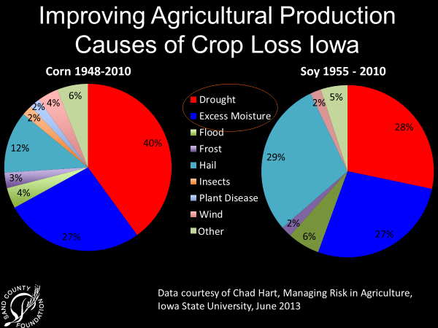

Farmers are keen to adopt techniques that minimize loss, and properly designed and installed drainage systems not only do that, but also increase both yields and land values. Drainage is the number one factor that affects crop yields.

While DWM systems can provide yield increases over conventional systems, additional yield boosts are obtained when sub-irrigation is added. A 12-year study in Northwest Ohio compared a field containing sub-irrigation to a field containing conventional unmanaged subsurface drainage. In dry seasons, corn yields in the sub-irrigated field increased by 108 percent compared to the conventionally drained field. While yield impacts will vary from year to year, average increases over the study were 35 percent.

An increase in crop production means an increase in revenue and land values. Therefore, it is in the producer’s interest to improve their drainage system management, and the discussion of how to increase revenue is readily accepted by producers.

However, looking solely at nutrient reductions and the ability to take advantage of emerging markets, there is a problem area: two of the structural practices that have the biggest off-farm impact on reducing nutrients and improving water quality have little or no on-farm benefit. These two practices – denitrifying bioreactors and saturated buffers – are both critical to achieving source water protection, but there is no economic (or regulatory) reason for a farmer to invest in these practices, even with significant assistance from governmental programs. Private sector engagement is critically needed to advance the installation of these two practices.

Major Competitors in Markets
There are other technical assistance and ecosystem services firms operating in our market area, but due to our team member’s experience level, reputations and personal relationships, ESE is uniquely positioned to quickly expand its customer base. Our IP Licensing Agreement and direct association with our sister company, Agri Drain Corp., also provides ESE with direct access to thousands of land improvement and water management contractors throughout the U.S. and Canada.

Product Marketing
ESE markets its services and products by working in partnership with both public and private entities, including USDA agencies, State Departments of Agriculture, Land Grant Universities, producer organizations, certified crop advisors, land management companies, land owners, farmers, pipe manufacturers, drainage contractors, and others.

As demand for nutrient credits grows, we expect to capitalize on the opportunity to design, monitor, and manage state-of-the-art conservation and water management systems using patented products, systems, and methods.

Key Personnel
Dave White, President of Ecosystem Services Exchange. Dave was a 35-year career employee of the USDA Natural Resources Conservation Service, rising from a technician’s aide to leading the Agency as Chief from 2009 through 2012. As Chief, he managed 12,000 employees and a budget of $4.2 billion. Dave redirected conservation programs toward targeted efforts designed to solve specific resource problems; particularly in the area of water quality and wildlife conservation. He has significant experience on Capitol Hill and helped develop the last three Farm Bills. Dave is also the Co-founder of the 9b Group, a benefit corporation devoted to consulting and lobbying for sustainable natural resource conservation.

Alex Echols, Executive Vice President of Ecosystem Services Exchange. Alex started his environmental career on Capitol Hill, working for the U.S. Senate for 12 years, writing key conservation programs like the Conservation Title of the Farm Bill and an extensive rewrite of bilateral and multilateral foreign aid programs. Alex subsequently worked for a trade association using market incentives to encourage use of recyclables. He spent six years at the National Fish and Wildlife Foundation as Deputy and then Acting Executive Director. In 2001, he set up a consulting firm to help industry, landowners, the conservation community, and government deliver more conservation for dollars invested. Alex is skilled at developing and implementing strategic action for philanthropic and corporate communities – helping develop conservation programs that fit their core values and deliver improved conservation return on investment.

Charlie Schafer, Founder of Ecosystem Services Exchange. Charlie is the product manufacturer and patent holder. Charlie began his career in the agricultural drainage industry in 1976, when he and two brothers began installing drainage tubing for Iowa farmers and began manufacturing products for their own projects and for other contractors. In 1984, they discontinued construction activities in order to focus fulltime on product development, manufacturing, and distribution. Charlie continues as President and owner of Agri Drain Corporation, a highly successful manufacturer of many proprietary and patented products and serves as the President of the Ag Drainage Management Coalition. He has held various offices as a Contractor and Associate Member of the Iowa and National Land Improvement Contractors Association, and has served on the Executive Board of the Conservation Technology Information Center and the National Association of Conservation Districts.

Paul Sweeney, Director of Conservation Planning. Paul Sweeney recently joined ESE after retiring from the USDA – Natural Resources Conservation Service concluding a 39-year career in natural resources conservation. He is a graduate of the University of Nebraska – Lincoln’s Agriculture College where he majored in natural resources. Paul’s leadership and conservation planning skills were developed while working in seven states; serving as a state Water Quality Project Manager; NRCS liaison to the Nebraska Department of Environmental Control and liaison to the Western Governors’ Association; State Conservationist and then team leader for two national teams for NRCS’s headquarters. In 2010, he led the development of the NRCS’s Ag Water Management Team and its goal of advancing the adoption of drainage water management and the associated environmental benefits.

Jace Klein, EIT Agricultural Engineering Tech. Jace is from Story City, Iowa. He grew up with a strong farming background and quickly developed a passion for conservation through groups like Ducks Unlimited and Pheasants Forever. He graduated from Iowa State University receiving his Bachelor of Science Degree in Agricultural Engineering and is currently pursuing a professional license in engineering. Jace is a graduate from the Overholt School of Drainage, a certified Technical Service Provider for the NRCS, and certified in ArcGIS from Iowa State. He joined ESE as an intern in February of 2015 and acquired full-time status in May of 2016.

Andy Mackrill, Conservation Planner. Andy is from Adair, Iowa. He has a bachelor’s degree in Environmental Science from Buena Vista University and is also a graduate of the Overholt Drainage School. He joined ESE in January of 2013 and has since been involved in planning managed drainage and sub-surface irrigation projects throughout the Midwest. Andy is a certified Technical Service Provider for the NRCS.

Esther Stabile, Administrative Assistant. Esther joined ESE in 2012, and is located out of the Ecosystem Services Exchange Florida office. Esther manages a variety of systems for ESE including accounting, billing and business management for ESE. Prior to joining ESE Esther was an independent business contractor. She brings this business experience and enthusiasm to ESE to help assure customer satisfaction at all levels.

www.unep.org/maweb/en/indes.aspx
www.nrcs.usea.gov/wps/portal/nrcs/main/national/technical/nra/ceap
Manitoba Agriculture, Food and Rural Initiatives. Soil Management Guide.
Allred, B.J. (2014) Crop Yield Summary For Three Wetland Reservoir Subirrigation Systems in Northwest Ohio. 30(6): 889-

